SX1018 Assessment

Ola Stefan Rudvin, 51549217

**Problem 1**. Suppose you are given a sentence A and you want to find out whether it is a tautology or a contradiction. How would you ascertain this using trees? Explain your answer.

A tautology is when no matter what values p and q have, the proposition p ⊃ q, q ∴ q is always true. A proposition that is false in every row is a contradiction.

For sentence A we first find the premises p, q and the conclusion q and write them down in argument form. Then we can conduct methods such as truth tables to see when the conclusion is true at different truth values of the premises. For truth trees, we complete the truth tree and see if there are any ‘open’ ends.

We find open ends by using the premises of the argument and the negation of the conclusion and using truth tree rules to find values for p and q that satisfy the new equation. If all the values of p and q satisfy the equation, the premises can lead to a negated conclusion which means the proposition is a contradiction. Vice versa, if all the ends close, the argument is a tautology.

**Problem 2**. (4 Marks) Suppose we have 2 names and a domain of 4 objects. How many different interpretations can be provided for these names over this domain?

A model of the predicate calculus has a domain. This is a non-empty set D of objects.

Let us set the domain to (Cat, Dog, Cow, Horse). With two names (Bob, Pat), we can interpret each name in four different ways including the possibility of both names using the same value from the domain. Therefore, there are 16 total possible interpretations provided for the names over the domain.

E.g. Bob(Cat) Pat(Cat), Bob(Cat) Pat(Dog) …

# Process Questions

**Problem 3.** (16 Marks) Use trees to test whether the following arguments are valid. If they are not valid, provide a counterexample model.

(1) (∀ z)(Sza ⊃ Tbz),(∀ y)(Tby ⊃ Uyc), Sca ∴ Ucc

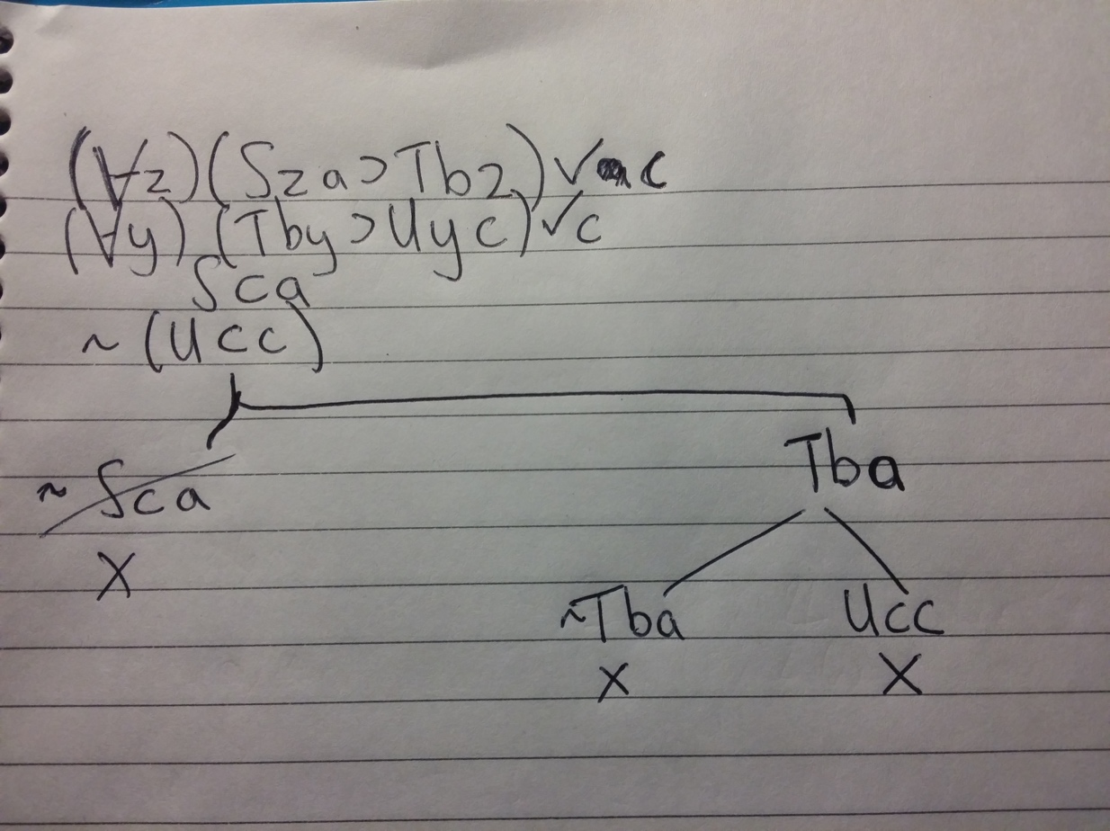For this question, there is an error where the Tba branch on the right is meant to be Tbc along with the ~Tba. I also skipped the opening of the modus ponens after Tba and put the results directly.

(2) (∀ x)(Px∨ Qx),(∃ x)∼Qx ∴ (∀ z)Pz

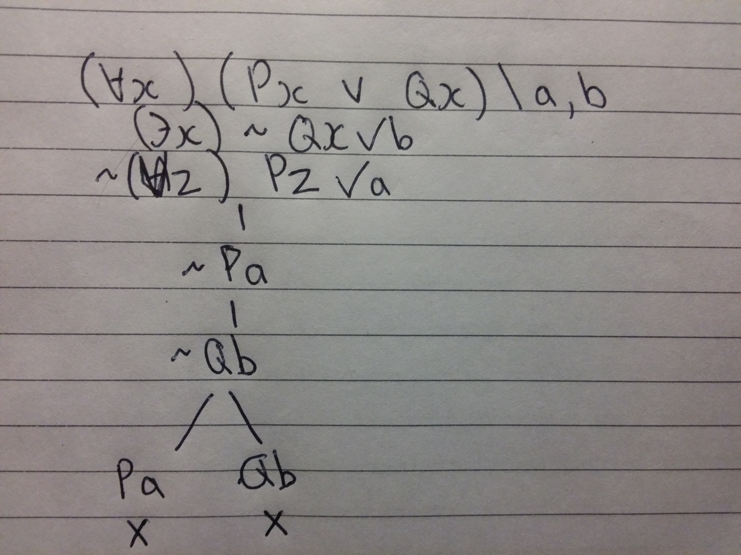

(3) (∀ x)(∀ y)(Rxy ⊃ Ryx) ∴ (∀ x)Rxx

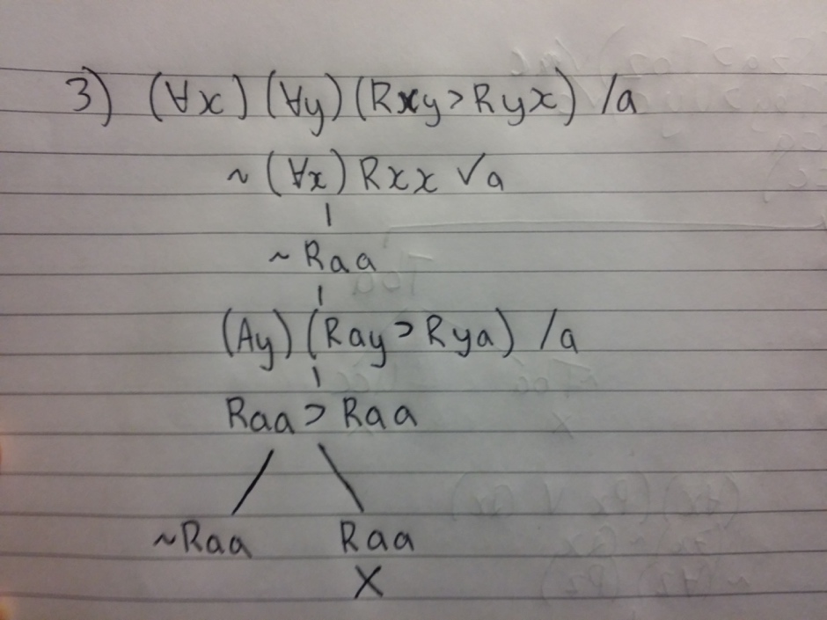Here the tree does not close, but at the bottom of the tree we notice the argument Raa ⊃ Raa, which translates to if Raa then Raa. Let Rxy = x reads why. With the domain of the world, the whole argument states that if the everyone reads books then the everyone reads books. Therefore everyone reads books. It is the use of premise in the conclusion that causes the argument to not be valid. This is of course completely dependent on which premise and conclusion are selected.  
(4) (∀ x)(∃ y)Rxy ∴ (∃ x)(∃ y)Rxy

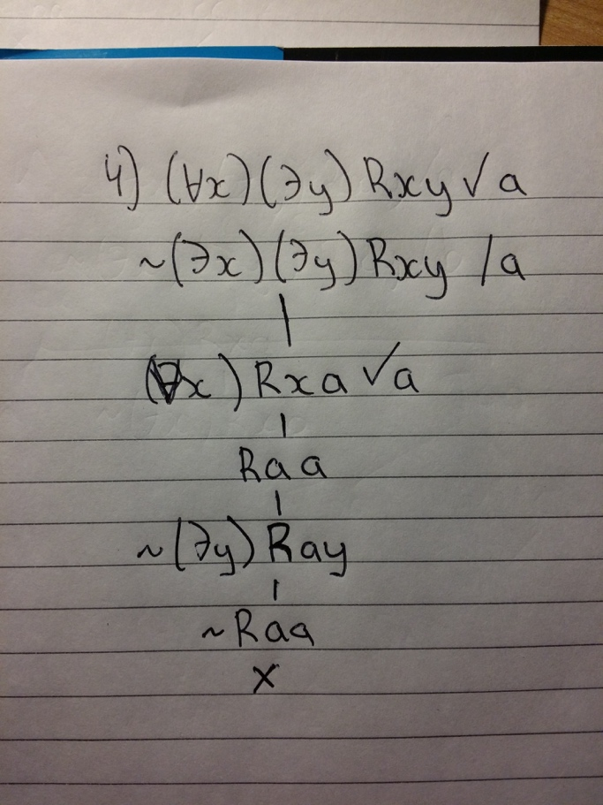¢

**Problem 3.** Problem 4. (8 Marks) Consider the following argument. Provide a dictionary and translate it into the language of predicate logic. Use a tree to assess its validity.

*Some boy danced with every girl. At least one girl has a car and all cars are made of metal. Therefore, there is a boy who danced with a girl who owns something metal.*

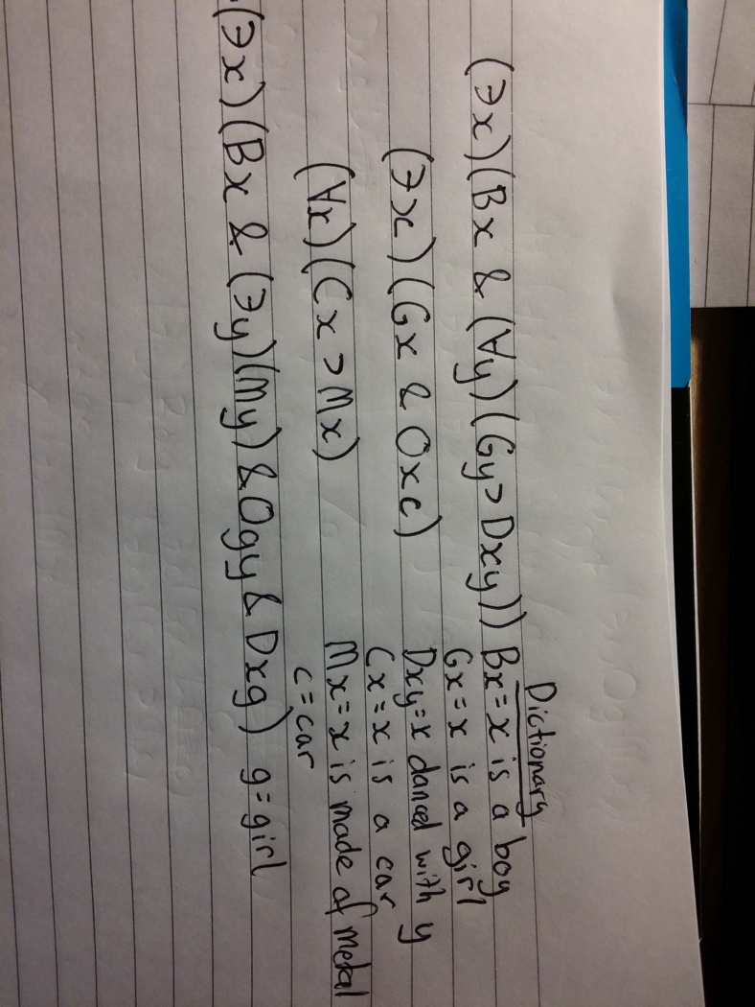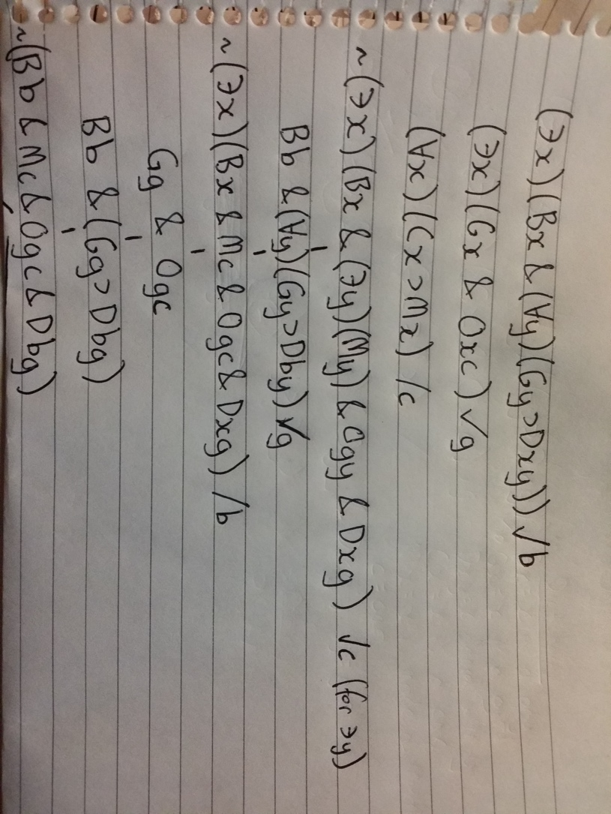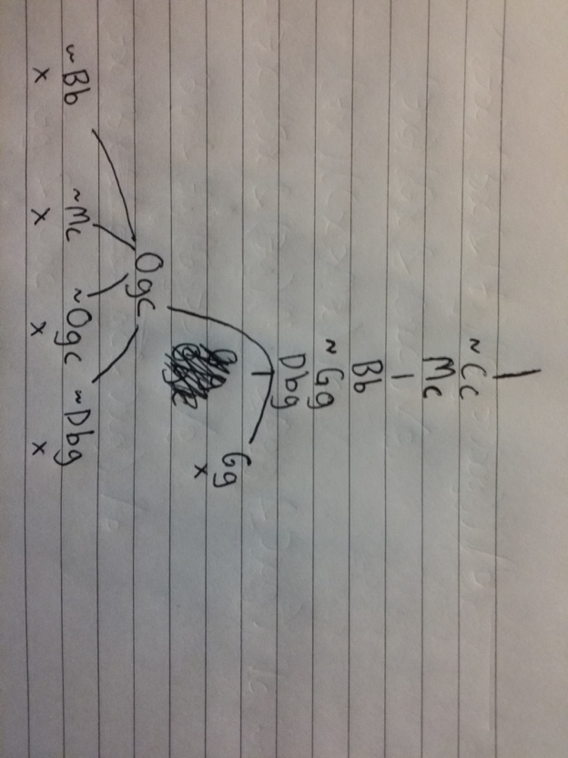

# Application Questions

**Problem 6.** (Linguistics - 6 Marks) What is Compositionality? Give an example of what is compositionally analysed. Given an example of what is not compositionally analysed.

Compositionality is when the meaning of an expression depends on it’s structure and smaller parts. In essence it looks at the parts of an expression that work together to form a greater argument. These parts also have rules that affect their outcome together.

Example of compositionally analysed: “Long Island Video.”

Example of not compositionally analysed: “Look!”

**Problem 7.** (Computer Science - 6 Marks) Find information about the Snomed medical ontology. Explain what the aim of the ontology is, and what are some of the things it can do. In your explanation it will be useful if you gave examples of the types of DL formulas that are used in Snomed.

Snomed is a grand medical computer capable of using logic to analyse and recommend patient data in hospitals around the world. With ontology Snomed can index and organise all of the data to provide further assistance in patient care such as decision making, recommended actions and extra information on the symptoms etc.

With a huge amount of data and 311,000 concepts to classify diseases and understand their parents and causes. With this information and the power of thesaurus-like features through ontology, Snomed can link and identify diseases that are written in different forms or even languages. Some description logic formulas it uses are role hierarchy and domain/range constraints. These formulas aid to classify symptoms and diseases for maximum efficiency and patient wellbeing.